# 

Student Non-Technical Sessions Workbook



# How to use this workbook

Please make sure you download a copy of this workbook template and share relevant parts with your Mentor.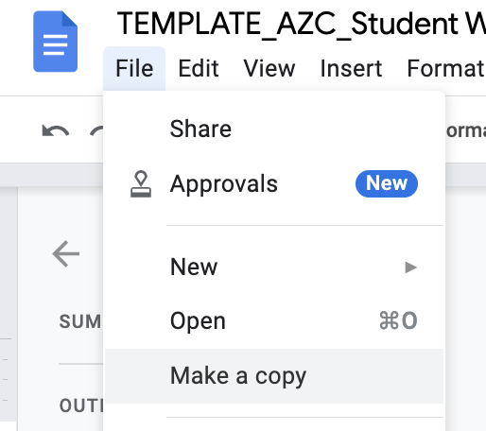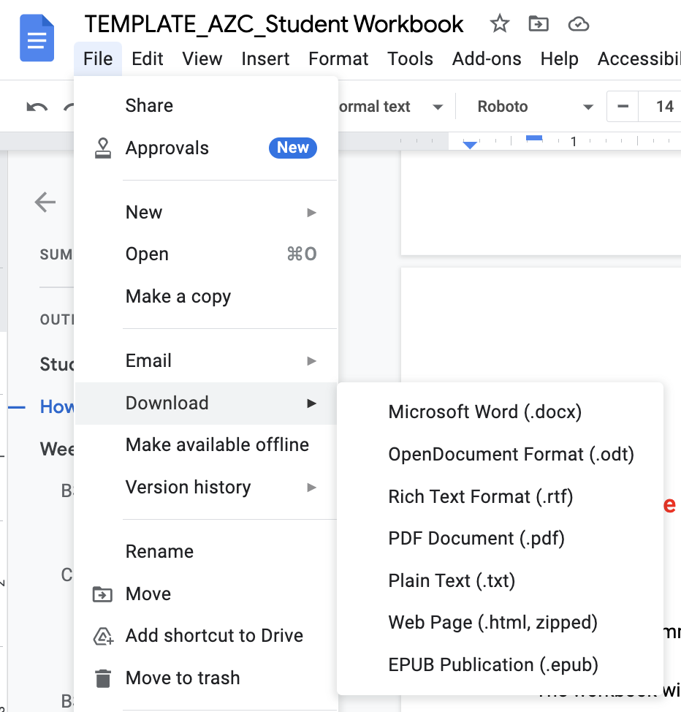

We highly recommend you use this workbook throughout your non-technical sessions to record and reflect your learnings.

The workbook will cover all non-technicals sessions (BSMs, EEs, SSMs and Community sessions)

Using this workbook often, will will help you once you graduate because you’ll be able to refer back to this useful information for CV writing, interviews, job searching and so much more!

You can use this document with your Mentor, and collect resources and ideas that might be shared via the discussion forums in Canvas or in your pod conversations.

# Week 1

## BSM: Introduction to Behavioural Skills and Mindsets

## 

| The 4 Generation Mindsets A **mindset** is a way of thinking that will help you in any situation that might come your way — **in your job or in life in general**. We will be learning and practicing four mindsets throughout this course.   1. **Growth Mindset** 2. **Persistence** 3. **Personal Responsibility** 4. **Future Orientation**   The other part of the BSMs is the Behavioural Skills. The below four, we know are vital to your success in this new career:   1. **Adaptability:** Adjusting one’s actions to each situation, even when in a changing environment 2. **Client Focus:** Prioritising the client’s needs and delivering a good client experience alongside the best possible solution 3. **Orientation to Detail:** Maintaining a close eye on detail when executing tasks so they’re completed with accuracy & thoughtfulness 4. **Teamwork:** When 2 or more people work together towards a shared goal |
| --- |

## C: Get and Give

## 

| Setting expectations is an important part of setting yourself up for success. Use this space below to record what you’d like to get out of the program. Be sure to check in at the end of the program and see how you did! | |
| --- | --- |
| What do you want to get out of this course and your time with Generation? | I would like to develop my communication skills and behaviour skills |
| How can you support others in their goal? | While my colleagues are moving towards their goals, sometimes they stack up and when I think they need me where they are, I try to produce solutions to their problems as much as my experience allows. |

## 

## BSM: Teamwork

| The Main DISC Communication Styles Communication is such a vital part of effective teamwork. Below are the main Communication Styles. The following page provides information of variations, if you are someone who sits in between two styles. [Learn more about how DISC works, and the styles here.](https://www.discprofile.com/what-is-disc/research-reliability-and-validity) | |
| --- | --- |
| **D - Dominant** | **I - Influencer** |
| * **Places emphasis on:** accomplishing results and “seeing the big picture.” * **Motivated by**: winning, competition, and success * **Prioritises:** taking action, accepting challenges, and achieving results * **Characteristics:** confident, sometimes blunt, strong-willed, determined, outspoken, and demanding * **Fears:** being seen as vulnerable or being taken advantage of * **Values:** competency, action, firm results, personal freedom, & challenges * **Influences others by**: assertiveness, insistence, competition * **Could improve by:** patience, empathy | * **Places emphasis on:** influencing or persuading others * **Motivated by:** social recognition, group activities, and relationships * **Prioritises:** taking action, collaboration, and expressing enthusiasm * **Characteristics:** enthusiastic, optimistic, open, trusting, warm and energetic. * **Fears:** loss of influence, disapproval, being ignored, rejection * **Values:** coaching & counseling, freedom to express, democratic relationships * **Influences others through:** charm, optimism, energy * **Could improve by:** being more objective, following through on tasks |
| **C - Conscientious** | **S - Steady** |
| * **Places emphasis on:** working conscientiously within existing circumstances to ensure quality and accuracy * **Motivated by:** opportunities to gain knowledge, show their expertise, and produce quality work * **Prioritises:** accuracy, maintaining stability, challenging assumptions * **Characteristics:** careful, analytical, systematic,, accurate, and tactful * **Fears:** criticism and being wrong; strong displays of emotion * **Values:** quality and accuracy * **Influences others by:** logic, exacting standards * **Could improve by:** acknowledging others’ feelings; looking beyond data | * **Places emphasis on:** cooperating with others within existing circumstances to carry out a task * **Motivated by:** cooperation, opportunities to help, and sincere appreciation * **Prioritises:** giving support, collaborating, and maintaining stability * **Characteristics**: calm, patient, predictable, deliberate, and consistent * **Fears:** change, loss of stability, offending others, letting people down * **Values:** loyalty, helping others, security * **Influences others by:** accommodation, consistent performance * **Could improve by:** displaying more self-confidence, sharing true feelings |

## 

| The DISC Variation Communication Styles The below are brief examples of variations. Maybe you feel you fall between two of the DISC profiles. Take a look below!  For more detailed information, go to the DISC website: <https://www.discprofile.com/what-is-disc/disc-styles> | | | |
| --- | --- | --- | --- |
| **D - Dominant** | | **I - Influencer** | |
| DC - Dominant/Conscientious | Di - Dominant/Influencer | iD - Influencer/Dominant | iS - Influencer/Steady |
| * Diligent, tough-minded, and creative, influencing others through their high standards and determination * Goals: independence, personal accomplishment * Fears: failure to achieve their own standards | * Results-oriented, vocal, and enthusiastic, influencing others through their charm and bold action * Goals: quick action, new opportunities * Fears: loss of power or status, invisibility | * high-energy, charismatic, and adventurous, influencing others through their boldness and passion * Goals: popularity, exciting breakthroughs, prestige * Fears: fixed environments, loss of approval or attention | * warm, friendly, and sociable, influencing others through their agreeableness and empathy * Goals: friendship * Fears: pressuring others, being disliked |
| **C - Conscientious** | | **S - Steady** | |
| CD - Conscientious/Dominant | CS - Conscientious/Steady | SC - Steady/Conscientious | Si - Steady/Influencer |
| * skeptical, stubborn, and disciplined, influencing others through their strict standards and resolute approach * Goals: efficient results, rational decisions * Fears: failure, lack of control | * cautious, orderly, and precise, influencing others through their practicality and attention to detail * Goals: stability, reliable outcomes * Fears: emotionally charged situations, ambiguity | * accommodating, patient, and reliable, influencing others through diplomacy and self-control * Goals: calm environment, fixed objectives, steady progress * Fears: time pressure, uncertainty, chaos | * Generous, approachable, and compassionate, influencing others by showing empathy and patience * Goals: acceptance, close relationships * Fears: being forced to pressure others; facing aggression |

## 

| My role in effective teamwork | |
| --- | --- |
| My DISC communication style is… |  |
| Practical ways I can tailor my communication style to work with… | Dominant type: |
| Influencer type: |
| Steady type: |
| Conscientious type: |
| Practical ways I can develop the other teamwork skills… | Collaboration: |
| Cooperation: |
| Mutual Respect: |

## BSM: Growth Mindset

## 

| Having a Growth Mindset Having a Growth Mindset is about seeing setbacks and challenges’, as opportunities to learn, develop and improve skills. [Read more here](https://hbr.org/2016/01/what-having-a-growth-mindset-actually-means).  We can strengthen our growth mindset, because the brain is able to rewire itself by making new habits and patterns to create new behaviour. Below we want you to practice rewiring your brain!  Refer to the ‘fixed mindset’ thoughts below, and come up with a way to answer these with a Growth Mindset.  Also use the space below to capture notes from the resource you select in the Canvas session. |
| --- |

## 

|  |  |  |  |  |
| --- | --- | --- | --- | --- |
| Recipe for Growth Mindset | | | | |
| **The current or proposed challenge** | **My initial reaction or thought** |  | How I can reframe the challenge | **Actions or steps to take to solve the challenge** |
|  |  |  | |  |

## 

## 

|  |  |  |
| --- | --- | --- |
| **Fixed Mindset Statement** |  | Growth Mindset Alternative |
| *“What’s the point. I’m never going to understand that concept”* | ***Example:*** *“This is a challenge for me, so I’m going to break it down into smaller steps, to make it more manageable to learn”* | |
| *“I keep being unsuccessful in interviews. I think I’m going to find a different career”* |  | |
| *“That feedback was so annoying. I’m good at what I do”* |  | |
| *Add your own here:* |  | |
| *Add your own here:* |  | |
| *Add your own here:* |  | |
| Space for notes | | |
|  | | |

## C: Team Building: Show and Tell

|  |  |
| --- | --- |
| Share your story Stories teach us about life, about ourselves and others. It is one of the most meaningful ways to build relationships with each other.  Sharing personal stories with your colleagues will develop an understanding, respect and appreciation, and promote a positive attitude towards each other.  In this activity, you will write down a personal story that you are willing to share with your colleagues. To do this, pick an item that is meaningful to you. It can be a picture or a book or plant or anything! Use this object to guide your story.  To help you form your story, use the following questions as prompts, adding notes to the ones you’d like to use. | |
| What was the most challenging moment in your life? |  |
| What do you most value and why? |  |
| Who is or was the most influential person in your life? |  |
| What is your dream or vision in life? Why? |  |
| What is the place in the world that is most important to you? |  |

## 

|  |  |
| --- | --- |
| **The importance of story-telling** | |
| Take a moment to reflect on why it’s important to know about people when working with them.  How can it help you? |  |

## 

# 

# Week 2

## BSM: Adaptability

| Dealing with change “Change is the only constant in life” - Greek philosopher, Heraclitus  Whether it’s a project change, a new team member, a new job, or a changing deadline, being able to adapt confidently is crucial. There are a number of ways for us to effectively practise this skill. Use the spaces below to record ways you can develop this muscle. You can also consider these questions each time you have to face a change on the job. | |
| --- | --- |
| What’s outside of my control with this change? |  |
| What’s inside my control with this change?  * What goals do I need to set? * What support do I need to make or deal with the change? * What small plans can I make right now to begin adapting? |  |
| Ways I can become cross-functional in my role to better adapt to workplace changes |  |
| Additional ways to practise adaptability (add your own too!):Take a different route to work or change your daily routine for a weekPractise some mindfulness which can calm nerves and help you gain a greater sense of perspective; stop what you’re doing and find 5 things in your surrounding you can see, 5 things you can hear, 5 things you can smell | |

## SSM: Maximising Online Learning

| Learning online has many advantages, but it’s not without its challenges too. Use the space below to plan for how you’ll stay focussed, connected and motivated throughout this course, and into potentially working remotely in your new role. | | |
| --- | --- | --- |
| Ways to stay focussed | Ways to stay connected to people | Ways to stay motivated |
| Example: Remove distractions around me when in class or work times. Set up a designated place to work, so I am not as distracted | Example: Utilise chat features to keep in contact with peers, like Slack and Zoom chat. Recommend we meet up in person where possible | Example: Give myself time goals and milestones to achieve with project work, and allow myself a reward when I complete them |
|  |  |  |
|  |  |  |

|  |  |
| --- | --- |
| Tips to stay healthy online | |
| Head and neck posture | To keep your neck, shoulders, and back free from injury, your head should be vertical to your neck. Consider mounting your laptop on a laptop riser and using an external keyboard and mouse. If you have a monitor, use books to raise it to a comfortable eye level, one that keeps your head and neck in that neutral, stacked position. |
| Hand and Wrist Position | Your hands and wrists should be in a neutral posture, similar to your head. Extend your arm and hand forward to lay them flat on the table. The hand, wrist, and forearm are practically flush, which is what you want. What you don't want is a hinge at the wrist. Adjust your workspace accordingly. You might have to change the height of the table or chair if possible, or move your keyboard and mouse closer or further away |
| Stand and Stretch | It’s important to move your position every 20 minutes or so. Get up, stretch your legs and arms. Get some water and allow your eyes to stretch and refocus by looking at things further away than your computer screen and then back again. |

## BSM: Persistence

| If at first you don’t succeed, try again There can be many ways of defining persistence. At Generation, persistence means finishing what you start and not giving up in the face of challenges. A persistence mindset means viewing challenges as something you can eventually overcome.  This means identifying challenges and working on solutions, not giving up, even in the face of criticism or rejection. It is important to note that sometimes it will be OK to recognise that an idea needs to completely change or be discarded. This is not a failure, this is the ability to recognise that a pivot is required.  Use the space below to record strategies to help you stay motivated and build persistence in the face of challenges and setbacks. | |
| --- | --- |
| When I face a roadblock or setback at work, I can demonstrate persistence by… |  |
| Strategies and practical things I can use to help me develop resilience and persistence |  |

## EE: Career Pathways 1 (CP1) Session

|  |  |
| --- | --- |
| Your Big Picture Statement, Staying Motivated and Getting Support When we learn new things, it can be overwhelming at times, and motivation can CERTAINLY drop!  You’ve taken the leap to learn new skills and advance your employment and even your life, so it’s important to take a minute to identify your Big Picture. Think of your Big Picture like a destination. You could have the best road map in the world at your fingertips, but if you don’t know where you’re trying to get to, the map is useless!  The destination may change slightly throughout this course, but it’s safe to say, the Big Picture will probably look similar. This can help you stay on track, keep you motivated, and remind you WHY you chose this course and career change for yourself. | |
| Why are you doing this course? |  |
| Why is this an industry you want to get into and why is it important for you to learn this topic/these skills? |  |
| How will doing this course, and gaining these skills, impact your life? |  |
| What is your Big Picture Statement? |  |
| How you will get support to keep motivation up?  * Who can help you be motivated? * what will help you stay motivated? |  |

## 

## 

## C: Introduce a Friend

| Creating connections for successful situations Whether it’s this program, or your new workplace, the connections your create with the people around you, will really impact your experience. We all have different stories, experiences, strengths and characterstics that make us unique and interesting, and the more we know about people, the more we can learn and work together effectively. | |
| --- | --- |
| What things do you share in common with your peers? |  |
| What differences are their in your group? |  |
| How can you use these similarities and differences to better work together? |  |

# 

# 

# Week 3

## 

## 

## 

## BSM: Orientation to Detail

|  |
| --- |
| Sometimes referred to as Attention to Detail, Orientation to Detail is a vital skill for you to have in your toolkit. As people working in technical industries, you’ll have first-hand experience in knowing that one small mishap, error in code, oversight, can make a HUGE difference to the end solution or product. Missing a small detail, can be the difference between your code or platform working, and it not.  There are a number of ways we can improve our Orientation to Detail. Review the tips below, and add more as you learn from your peers and gain experience on the job. |
| Tips for improving your Orientation to Detail  * **Single tasking vs. multi tasking:** We are generally taught that multi-tasking is a strength, but when we handle multiple tasks at one time, our attention is divided amongst those tasks, and therefore things can get missed. See where it’s possible for you to single-tasks. Perhaps when a deadline is close, or a project is very important, where can you delegate, or deprioritise other work to single-task and make sure * **Active Listening:** We might think we’re listening, but are we really? Often when someone is speaking we are either thinking of our next sentence or reply or we can sometimes also get distracted by our surroundings, their movements and non-verbal communication, or even our own personal thoughts. When we actively listen, we really pay attention, and when we do this, we are more likely to pick up on more details and information! * **“Measure twice, cut once”:** This is a carpenters saying, but the same message applies to your work. Test, test, hypothesise, trial, make versions, before you press the final go button * **Peers review:** If we’ve been staring at something for so long, we can likely miss something right under our noses! Where possible, have a colleague review something that’s very important to see what they may pick up in the detail that you could have missed. * **Break it down (time management)**: If something is very detailed and specific, break it down. Make a checklist of everything that needs to be crossed off and considered. Review this regularly to make sure nothing’s been left off. * **Walk away and come back to it:** The work you’ll do will likely see you, staring at the screen for a number of hours! Make sure to get up, stretch, have a walk and come back to it when you are refreshed. When we are rested, or take a break from the specific task, we often come back to it with ‘new eyes’ and see something we didn’t the first time around. |

|  |  |
| --- | --- |
| Practising my Orientation to Detail skill Use the space below to plan for how you can use the tips for different situations. Keep adding resources and tips and you discover them. | |
| Tip | What ype of task or situation can I use this with |
| Example: Peers review | Example: When initially building my wireframe, I could get a colleague to look over it to make sure my pathways make sense and I haven’t missed anything |
|  |  |
|  |  |
|  |  |

|  |
| --- |
| Further resources to support your Orientation to Detail The below platforms can help you stay focussed, and not miss the small, but very important details:   * [**Grammarly:**](https://www.grammarly.com/?q=brand&utm_source=google&utm_medium=cpc&utm_campaign=brand_f1&utm_content=sa360test&utm_term=grammarly&matchtype=e&placement=&network=g&gclid=EAIaIQobChMIkLOfpveh-AIVF5FmAh058wiZEAAYASAAEgIqaPD_BwE&gclsrc=aw.ds) A free website and plug in to check your spelling and grammar * **Project Management Tools:** [Asana](https://asana.com/?noredirect), [Monday](https://monday.com/) & [Trello](https://trello.com/en) are just a few ways to organise your work and make sure you keep on top of everything * We’ve curated this [LinkedIn Learning Path](https://www.linkedin.com/checkpoint/enterprise/login/100575394?pathWildcard=100575394&application=learning&redirect=https%3A%2F%2Fwww%2Elinkedin%2Ecom%2Flearning%2Fpaths%2Fgeneration-orientation-to-detail%3Fu%3D100575394) for you to help with developing your skill |

## C: Team Building: Life Highlights

## 

| Reverse Bucket List Sharing life highlights with your peers can really help you connect and motivate each other.  Sometimes it may be hard to think of what we've achieved or where we've been successful. A success is simply something we said we'd do and did. That can be as minor as getting up with our alarm and starting the day, to moving countries or house. You define success for you!  A reverse bucket list, is the opposite to a bucket list; rather than listing everything you’d like to achieve in your life, a reverse bucket list is an opportunity to stop and reflect, and list all the things you’ve ALREADY accomplished in your life.  You may find it helpful to speak with loved ones and close friends to get some support - often these people can quickly tell us achievements before we see them in ourselves. Another helpful tip is to think about your day today to gt you started.  Have you attended classes? Did you get up and get yourself organised? etc  Make your collection below, and keep adding as you achieve more and more! | |
| --- | --- |
|  |  |
|  |  |
|  |  |
|  |  |
|  |  |
|  |  |
|  |  |
|  |  |
|  |  |

## BSM: Personal Responsibility

| Personal responsibility, sometimes also referred to as personal accountability, is the skill to own your tasks, your part in the larger project, and to have pride in that ownership to produce quality work.  The Responsibility Ladder is a tool to help you identify your reactions to a situation, and what steps you might take to solve a problem or situation. | |
| --- | --- |
| What types of ‘things’ do I normally tell myself as to why something might be too hard to finish, do, own? |  |
| How could I work around each excuse/reason? |  |
| When I notice I’m ‘below the line’, I will get myself ‘above the line’ by… |  |

## SSM: VIA Character Strengths

| VIA is an organisation that teaches people about their strengths. VIA’s survey has been used in hundreds of research studies and taken by over 3 million people in over 190 countries in the world.  The character strengths are 24 universal strengths that have been identified after thorough research. The 24 strengths are grouped into 6 “virtue” categories. A virtue is an overall quality of excellence. Virtues are similar to strengths, but they are broader categories. For example, one virtue, “Courage,” has four specific strengths that fall within it. [View more about the Character Strengths in this PDF](https://drive.google.com/file/d/1yM7zqlBGDFpPZcDX8LB2bK3Vom4-qCTy/view?usp=sharing) | | | | | |
| --- | --- | --- | --- | --- | --- |
| Wisdom & Knowledge Cognitive strengths that entail the acquisition and use of knowledge | Courage Emotional strengths that involve the exercise of will to accomplish goals in the face of opposition, external or internal | Humanity Interpersonal strengths that involve tending and befriending others | Justice Civic strengths that underlie healthy community life | Temperance Strengths that protect against excess | Transcendence Strengths that forge connections to the larger universe and provide meaning |
| * Creativity * Curiousity * Judgement * Love of Learning * Perspective | * Bravery * Perseverance * Honesty * Zest | * Love * Kindness * Social Intelligence | * Teamwork * Fairness * Leadership | * Forgiveness * Humility * Prudence * Self-Regulation | * Appreciation of Beauty and Excellence * Gratitude * Hope * Humour * Spirituality |
| My character strength/s is/are: | |  | | | |
| How I can use my strengths to support me when learning new things or building a skill: | |  | | | |

## BSM: Client Focus

|  |  |  |
| --- | --- | --- |
| Client Focus Whether you have direct contact with your client or not, you should always have them in mind when developing, designing or creating.  Often the tech department is seen as a ‘shared service’ within the business, alongside finance and HR, so it’s important to also think about your internal clients (that is, the teams you work closely with and the other functions of the business you support with your skills and services, such as sales and development)  Depending on the industry you are working in, clients may be referred to as customers, and you may also hear the term ‘customer-centricity’ used by leaders. To have a client-centric or customer-centric approach, means to centre your work, thinking, solutions around your customer. | | |
| Best Practise for Exceptional Client Focus | | |
| Who are my main types of clients, customers or stakeholders in my project |  | |
|  | Topic | My Notes |
| Effective Communication with a client | The communication style of the main contact we’re dealing with: |  |
| How informed and involved they want to be in the project: |  |
| When is it appropriate to use each different method of communication:   * Slack or instant messaging * Email * Phone call * In person meeting * Video conferencing meeting |  |
| Verbal and non-verbal communication:   * Verbal: what I say, how I say it, tone, speed, volume * Non-Verbal: body language, gestures, eye contact, facial expression, mirroring * What else might be important to consider with my clients (e.g. cultural beliefs) |  |

# 

# Week 4

## 

## 

## 

## 

## BSM: Future Orientation

|  |  |  |
| --- | --- | --- |
| Begin with the end in mind In your Career Pathways 1 session, you began looking at where you want to be, and why you are doing this course. The Future Orientation Mindset is all about being able to see your goals clearly, and build plans to help you achieve them in a realistic, specific and measurable manner.  Future Orientation is like having a custom-made roadmap for you! If you know where you’re starting from, and know where you want to get to, you can plan the possible routes along the way. | | |
| Step 1: Where I am now *(E.g. graduated, looking for a role)* | Step 3: The steps and potential routes I can take along the way to get there  *(E.g. In each space below, create a different SPECIFIC experience that helps you achieve the end goal)* | Step 2: My end goal/s |
|  | #1 | Goal #1 |
| #2 |
| #3 | Goal #2 |
| #4 |

## EE: Transferable Skills Session

|  |  |  |  |
| --- | --- | --- | --- |
| Transferable Skills Defined  * Natural skills and abilities you possess * Learned skills and abilities you've picked up from previous personal and professional experiences * Often thought of as 'soft' or 'people' skills & include, leadership, communication, maybe even technical   Look at the below skills and highlight the ones you think you have. Ask your Mentor, peers and family too as they may see skills you don’t! | | | |
| Transferable Skills List | | | |
| Communication Skills | Analytical Skills | Management Skills | Technical Skills |
| * Oral communication * Written communication * Interpersonal communication * Non-verbal communication * Listening * Presentation * Public-speaking * Relationship-building * Small talk * Rapport-building * Negotiating * Persuading * Discussion | * Brainstorming * Communication * [Conceptual](https://zety.com/blog/conceptual-skills) * [Creativity](https://zety.com/blog/creative-thinking-skills) * Data and metrics interpreting * Data mining * Diagnostics * Forecasting * Organization * Problem-solving * Reporting * Research * Theorizing * Troubleshooting | * People management * [Project management](https://zety.com/blog/project-management-skills)   + Strategic Planning   + Subject Matter Expertise   + Project Lifecycle Management   + Agile Software   + Scrum Management   + Meeting Facilitation   + Financial Modelling   + Kanban   + Forecasting   + Lean Thinking   + Performance Tracking   + Budgeting * [Time management](https://zety.com/blog/time-management-skills)   + Prioritizing   + Delegation   + Decision-making   + Goal setting   + Multitasking   + Problem solving   + Strategic thinking   + Scheduling   + Managing appointments   + Record keeping * Conflict resolution * Finance * Budgeting * Logistics * [Organizational skills](https://zety.com/blog/organizational-skills) * Recruitment * [Presentation skills](https://zety.com/blog/presentation-skills) * Action planning * Risk management | * Office suites ([MS Office](https://zety.com/blog/microsoft-office-skills), G-Suite, iWork) * Database management * Social media * Web (HTML, CSS, CMSs, SEO, etc.) * Troubleshooting * Equipment installation and configuration * Graphics * Equipment maintenance * Analytics * Typing * [IT skills](https://zety.com/blog/it-skills)   + Coding languages: Python, HTML5, JavaScript, CSS, PHP, SQL, C++, Ruby, .NET.   + Operating systems: Linux, Windows, masOS, Android, iOS.   + Cloud computing: Azure, AWS, Google Cloud, Amazon Web, Kamatera, Oracle   + eCommerce Platforms: Shopify, WooCommerce, BigCommerce, Magento, OpenCart.   + Network security: Cloud security, malware analysis, intrusion detection, CEH, OSCP, CISA, GCIH, secude code development, data and file encryption.   + Data analysis: OLAP, data queries, data cube technology, raw data processing and integration, data structures and algorithms, Tableau.   + AI: machine learning, natural language processing, AI integration and application.   + Application and desktop software development: Android/iOS Software Development Kit, Android/iOS UX and UI, SQL, Xcode development, Github, React.js, Angular. |

List credit: zety.com

|  |  |  |
| --- | --- | --- |
| My Existing Transferable Skills | | |
| Take time to record your transferable skills in the below table.  Being able to quickly recall these skills will help with your interview practice and further skill development. | | |
| Skill Name | Where I developed it | How it will relate to my new career path |
| Example: Resourceful | Example: When having to take over the family business at a young age and other general life experiences | Example: As a cloud developer it means I will be a self-starter, who can find answers for myself rather than relying on my team. |
|  |  |  |
|  |  |  |
|  |  |  |
|  |  |  |

## 

# Week 5

## C: Now and Then

|  |  |
| --- | --- |
| From here to there Building on from your BSM Future Orientation, use the space below to visualise in more detail, where you are right now in this moment, and where you’d like to get to by the end of the program. Think not just about the role you’d like, but how you’ll feel, what you’ll be doing, what does your environment look like. | |
| Date: | Date: |
| Where am I now: | Where will I be: |
| How I feel at right now *(be creative ad use Emojis if you like!):* | How I’d like to feel: *(be creative ad use Emojis if you like!)* |
| What I can do now to help me get there: | I will know I’m ‘here’ once ….. happens |

## BSM: BSM Challenge 1

## 

|  |
| --- |
| Record your notes here for the challenge |

## 

# Week 6

## EE: Career Pathways 2 Session: Different Career Avenues

|  |  |
| --- | --- |
| Guest Speaker Reflection There are SO many avenues once you have experience as a Cloud Practitioner, but some are more realistic than others, for recent graduates.  This session exposes you to some professionals working in the most likely fields and will be followed by reflection time for you to think about what your interests are and where you think you’d like to work. | |
| What stood out to me from the speakers? |  |
| What more do I want to know about any of the avenues? |  |
| What additional skills do I want to learn post program? |  |
| What experiences could I take on to help me gain the skills for my ideal avenue? |  |
| Additional notes |  |

|  |  |  |
| --- | --- | --- |
| Building Skills Plan with the 70:20:10 learning model **The 70:20:10 learning model helps you manage your time to build skills practically.**  *70% of your learning should come from practical experience on the tools*  *20% from coaching, mentoring, peer collaboration*  *10% from training courses, online courses*  Reflect on the Transferable Skills session and the BSM: Future Orienation Sessions, and what you learnt about Career Avenues from this session before researching and recording ways you can build PRACTICAL SKILLS & EXPERIENCES with the 70:20:10 Learning Model.  Upon graduation, we encourage you to invest in the 70% learning opportunities, that will help you build experience, skills, examples for your portfolio and more confidence with the tools you’ll need on the job. | | |
| **Building skills – 70% (through practical experiences)** | | |
| Name and contact info | What skill/s can I build | How it will help me build the skill |
| *Example: upwork.com* | *Example: freelance tech skills, practical cloud application skills* | *Example: If I work with building this project , I will have direct practical experience which I can use for my portfolio to obtain employment. It will allow me to practise in real-time.* |
|  |  |  |
|  |  |  |
|  |  |  |
|  |  |  |

|  |  |  |
| --- | --- | --- |
| **Building skills – 20% (through peer chats, mentoring, coaching)** | | |
| Name and contact info | What skill/s can I build | How it will help me build the skill |
| *A volunteer coach provided by Generation when I graduate* | *I want to build on my networking skills* | *I’ll be able to learn off someone who’s more experienced than me with this skill, learn how they made a successful career in what I want to do, and help me network and understand more about the industry* |
|  |  |  |
|  |  |  |
|  |  |  |

|  |  |  |
| --- | --- | --- |
| **Building skills – 10% (additional training, courses)** | | |
| Name and contact info | What skill/s can I build | How it will help me build the skill |
| *CodeCademy Course* | *Python advanced* | *The course will teach me the next level of Python skill i require for my ideal jobs* |
|  |  |  |
|  |  |  |

## SSM: Imposter Syndrome

## 

| You are worthy! Imposter syndrome is the belief that one’s success, achievements or situation are not deserved. This belief is accompanied by feelings of inadequacy, unworthiness or fraudulence. The good news is, we can put strategies in place to help us overcome the feelings of imposter syndrome, and get on with doing the job, enjoying the achievement, starting the new experience, with confidence and pride! | |
| --- | --- |
| Strategy name for handling Imposter Syndrome | What it looks like in practise |
|  |  |
|  |  |
|  |  |
|  |  |
|  |  |

## 

# 

# Week 7

## BSM: BSM Challenge 2

## 

|  |
| --- |
| Record your notes here for the challenge |

## 

# Week 8

## SSM: Responding to Initial Failure

## 

| Failure is something EVERYONE experiences and it’s very normal to react to failure or disappointment. The key to moving through it is your ability to be resilient, and switch into a Growth Mindset to work through the failure and see it as an eventual opportunity.  It’s healthy to process your emotions and initial feelings around failure, so use the space below to do so! | |
| --- | --- |
| How I feel initially when something doesn’t go right | What I can do about it, to feel better, and turn it into something productive |
|  |  |
|  |  |
|  |  |
|  |  |
|  |  |
|  |  |

## SSM: Resolving a Conflict in the Workplace

|  |  |
| --- | --- |
| Conflict doesn’t mean a fight. Conflict occurs because workplaces are made up of diverse people with different opinions. Conflict can arise over information, resources, opinions, processes.  When conflict is handled professionally and respectfully, if can actually help to shed light on new perspectives and ideas. When conflict is managed effectively, you can see it as an opportunity!  The below provides some elements to resolving conflict and tips for you to consider | |
| Providing Feedback in the workplace | WHY: Check your motives  Before giving feedback, remind yourself WHY you are doing it. The purpose is to improve the situation or person’s performance, not to have a ‘vent’. You won’t accomplish much by being harsh, critical or offensive. |
| HOW: Environment and timing  Be prepared to receive feedback too. For this reason, and for consideration of the other person, think about the where and when for the feedback to take place. |
| WHAT: To say or not to say  Generalised comments don’t provide enough information for people to know how or what to improve. Try limit it to 1 or 2 points as to not overwhelm! |
| Tips to minimise conflict or resolve it |  |
| Steps I will take when facing a conflict… | 1.  2.  3.  4. |

## 

# 

# Week 9

## 

## C: Team Building: Marooned on an Island

## 

|  |
| --- |
| Record your notes here |

## EE: Interview Practice Session

|  |
| --- |
| Interview Tips and Tricks Below are some tips and tricks to get you started. Use the below blank spaces to add anymore you discover from your peers! |
| Don’t REHEARSE...RESEARCH instead  * If you script yourself for interviews, chances are you’ll add unnecessary pressure and stress on yourself * Instead on trying to memorise examples from your work experience, and which questions they will answer, review your CV and work experience, and find a few achievements that you are confident in talking about *(it’s very likely that one example from your past jobs, could answer a number of questions, such as time management, communication, problem solving etc)* |
| Use the STAR or SAR Method for interview answers   * S - Situation - Set the scene/context and what was happening * A - Action - Describe the specific actions you took to handle the task. * R - Results - Describe the outcome of your actions/ efforts. * (The T is for tasks that you were assigned or had to do, which is sometimes combined whe (S) to make SAR) |
|  |
|  |
|  |

The image is of an acronym that spells out the word IMPRESS.

I = Introduce: Introduce yourself clearly and briefly. Example; "Tell me a bit about yourself", doesn't mean to tell your whole life story!

M = Make Eye Contact; Eye contact shows confidence, interest, and relationship building.

P = Posture; Stand or sit tall, open arms and body language, dropped shoulders, relaxed face

R = Research; Research the company and the interviewers if you can. Also, reflect on your experience, without rehearsing examples

E = Enthusiasm; show a bit of energy and enthusiasm for the role. If you sound and look like you don't want to be there, or you're unsure, the employer will be unsure too!

S = Speak Clearly; Slow down, take breaths, watch your "Umms, Aahhs and Likes". Practise with a friend, in the mirror, or record yourself. Did you understand yourself?

S = Smile; Smile on the phone, smile in person, smile to boost confidence!

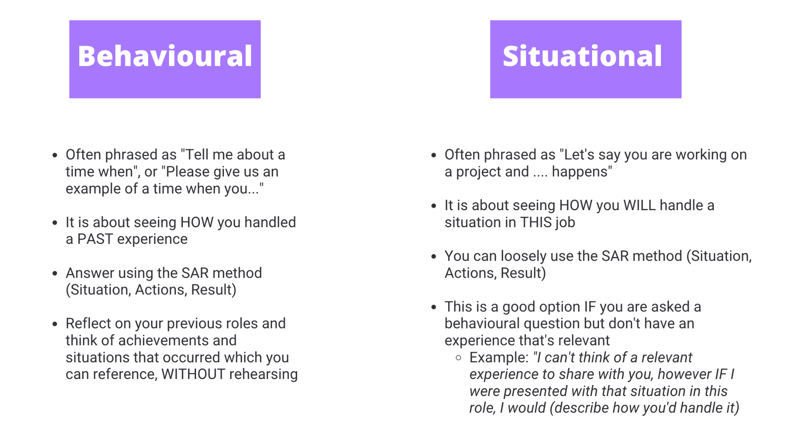

## BSM: BSM Challenge 3

## 

|  |
| --- |
| Record your notes here for the challenge |

## EE: CV Fundamentals and Intro to CV Day Session

* 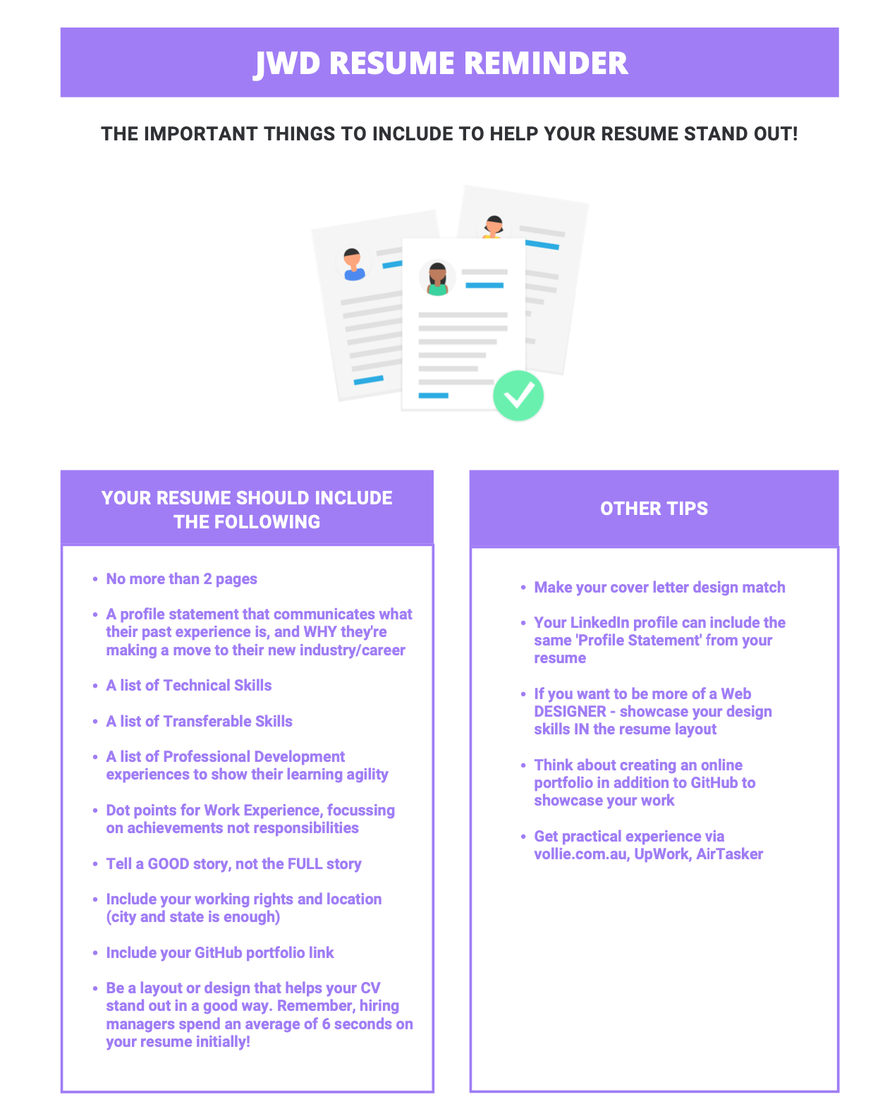**Tell a good story not a full story**
* **Feature:**
  + Contact details
  + Profile Statement / About Me
  + Technical skills
  + Transferable skills
  + Education background
  + Professional Development
  + Experience section with dot points & achievements
  + References section
* **Design is important!**
  + Recruiters take an average of 6 seconds to view your CV
  + The CV is the first opportunity for you to show off your skills
  + Have your cover letter match your CV
  + Ask yourself “so what?” to every point you include
    - (what’s it saying about your skills?)

### 

|  |
| --- |
| CV Checklist After completing the lessons on CV, review your existing CV to start thinking about what you might need to change when we have the CV Workshop Day. |
| Overall design  * What does the design and layout say about me now? * Is it easy to read and pick up on my skills? * Does it help me stand out in a good way? |
| Profile Statement  * Does it explain why I’ve made a career change? * Does it highlight my skills and experience briefly? * Does it help show my personality? |
| Skills lists  * Do I have clearly defined technical skills and transferable skills listed on my CV? * Are the skills listed ACTUALLY things I can do/use practically? |
| Education and Professional Development sections  * Have I got my education on there? * Have I listed this course “Generation Australia in partnership with AcademyXi” * Do I have a relevant list of my professional development like Codecademy courses, certifications etc? |
| Experience section  * Is it in chronological order with most recent at the top? * Do i have dot points to clearly show what I achieved in the role? * Have I used measurable ways to SHOW HOW I achieved those thing? * Is what I’ve got there actually important, and communicating something valuable about myself? |
| References  * Do I say ‘References available on request’? (we recommend this!) |

### 

### 

### 

### 

## 

### 

### 

### 

# Week 11

### 

## EE: CV Workshop Day

|  |  |
| --- | --- |
| In this Workshop Day, we will go through drafting your CV and seeing how it relates to the Cover Letter.  Below is a space for you to record anything you’d like to keep editing or anything you still need to work on before providing your CV to our Placement team.  We HIGHLY recommend sharing your CV with your mentor before graduation, so that you can get feedback on what to improve, ready for placement, post graduation! | |
|  | CV Notes |
| Layout |  |
| Main Sections  * Heading * Contact Details * About Me/Professional Statement * Skills (Technical and Transferable) * Education * Professional Development * Work Experience/Career Experience * References   If you can fit it or if you don't have much professional experience:   * Interests/Hobbies * Volunteering Experience |  |
| Profile Statement Your profile statement to include the following:   * Degree/education * Years of experience in previous work * WHY you are moving to web dev career * What skills/experience translate across * What you love about web dev * Career objective or aim |  |
| Skills List  * Technical Skills * Transferable Skills |  |
| Career Experience  * Your experience section should highlight achievements and also list them in order of relevance to the job requirements of a job ad * Make it easy for the reader to scan your CV and find their keywords and required skills * Think about sub-headings in bold to make it even easier * Make each line count. Make it measurable and specific so the reader can visualise what you'd be like in their role * Ask yourself, "So what?" to each line. if you don't know, remove it! |  |
| Cover Letter | |
| Main Sections |  |
| Tailoring  * Have I personalised the letter? * Have I featured keywords from the job advert? |  |

## 

## 

## 

# Week 13

### 

### 

### 

### 

### 

### 

## 

## C: Peer Appreciation Notes

## 

| What are you grateful for? You’ve covered SO much in this program, so we’d like you to take a moment to breathe and think about just how much has been achieved.  Use the space below to record your gratitude moments, and copy in any notes from your peers that you’d like to remember for years to come! | |
| --- | --- |
| What are you grateful or thankful for, from this course? |  |
| Use this space to copy in some of the nice things people said about you in the online activity |  |

## EE: Introduction to Portfolios

| Below is a for space you to record anything you’d like to keep editing or anything you still need to work on to make sure your portfolios are ready for employers and applications | |
| --- | --- |
| Does my portfolio feature the following:  * + Name and picture   + Digital Presence   + About Me   + Experience   + Skills   + Projects   [More detailed checklist items here](https://docs.google.com/document/d/1PQCgPIC2ju0vMRSFGmH0HcmBOpid9Tz2d5yDyu8yN-8/edit) |  |
| Additional Portfolio Notes and Resources |  |

## BSM: BSM Challenge 4

## 

|  |
| --- |
| Record your notes here for the challenge |

## EE: LinkedIn

|  |  |
| --- | --- |
| Employers really want to see you connect with LinkedIn!  Making sure you have a professional and relevant profile, where you engage with other industry professionals by writing, commenting and learning, REALLY helps you stand out and get noticed!!  Below is a space to check off what your profile covers, and record notes on what you need to edit in the main areas of LinkedIn | |
| Profile  * Clear photo, professional and relevant to the jobs you want * Relevant headline with keywords from your industry to help recruiters search you * Updated Skills list that connects you to your industry *(tip: check out the skills listed in the job descriptions you’d like - this shows you what recruiters are ultimately looking for)* * Clear ‘About Me’ section * Experience section is clear and not too long |  |
| Follows, Hashtags and Connections  * Following relevant hashtags to keep up with industry trends * Follow hashtags as a way to search for job opportunities * Feature relevant hashtags in your posts to get connected to the right networks * Following relevant companies and thought leaders * Send a follow up note when you request to connect with someone to make it more personalised |  |
| Job Searching  * Use filters to narrow down a search and be more purposeful * Search company employees first so you can personalise an application to the talent, recruitment or hiring manager |  |
| [**(***Download this LinkedIn Profile Template)*](https://drive.google.com/file/d/1h-44Ktdf0KmJpSdBvq7eIHvkAkBU8QPN/view?usp=sharing) *if you don’t want to edit directly your profile right now* | |

## EE: Career Pathways 3 Session: Job Search and Applications

|  |  |
| --- | --- |
| By now you’ve got you’ve graduated and should have CV and cover letter templates ready to go or close to it! The next step is to start applying if you haven’t been offered something already! It's all about searching smarter not harder!   * We recommend you start your search off small and specific. * Think about WHERE you want to work, and under what conditions. * A general application and cover letter are felt by the hiring manager. * BE specific: why that company? (managers are more likely to be interested in your application). * Use the below Smarter Job Search table to record your preferences | |
| Category | Your preference and considerations |
| Location  * What locations are you open to? * Would you relocate? * Only interested in working from home? * How far in kms are you willing to travel? |  |
| Industry  * Is there a particular industry you want to work in? * The previous industry you worked for could be a good transition into the new career? * Is there a cause or topic you’re passionate about? |  |
| Time   * What’s your availability? * Full time, part time, job-share, casual, remote, flexible for kids, freelancing, fixed-term? * Can you/do you want to, do international hours? |  |
| Work Benefits   * Need flexibility for children? * Longer or paid paternity/maternity leave? * Other health benefits or discounts? * On-the-job training? |  |
| Other |  |
| Here are some more tips and tricks for making the job search and application process, work for you!**Use filters on job sites**  * Start with the most recent roles, or roles advertised in the last 7 days and then open up the search from here (this gives you the best chance to be one of the first to apply and have your application seen * Sites like LinkedIn have HEAPS of filters including kms from your location, years of experience required, types of companies, keywords etc   **Look on different sites to increase your chances**   * Not all companies will advertise on the same job boards/sites   **Know what you’re looking for**   * Be specific - what kind of company do you want to work for? What’s important to you in a role? Then go to job boards that are more likely to feature those kinds of ads   + E.g.: EthicalJobs.com.au for charities, Not For Profits, education and medical, or Mumbrella for jobs in the creative industries   **Tailor your Cover Letter (and even CV!)**   * If you really want the job - put the effort in to tailor your CV & cover letter. Be sure to feature the keywords they’re using in the job description * Reorder your achievements to be of most relevance to the job requirements * Match the language and tone to their company (i.e. if it’s a start up that’s informal, lose the “I’m delighted to formally apply for…”)   See more resources on our GenAus Job Search site, powered by google: ​​[GenAus Job Searching Google Site](https://sites.google.com/generation.org/genausjobsearching/home) | |

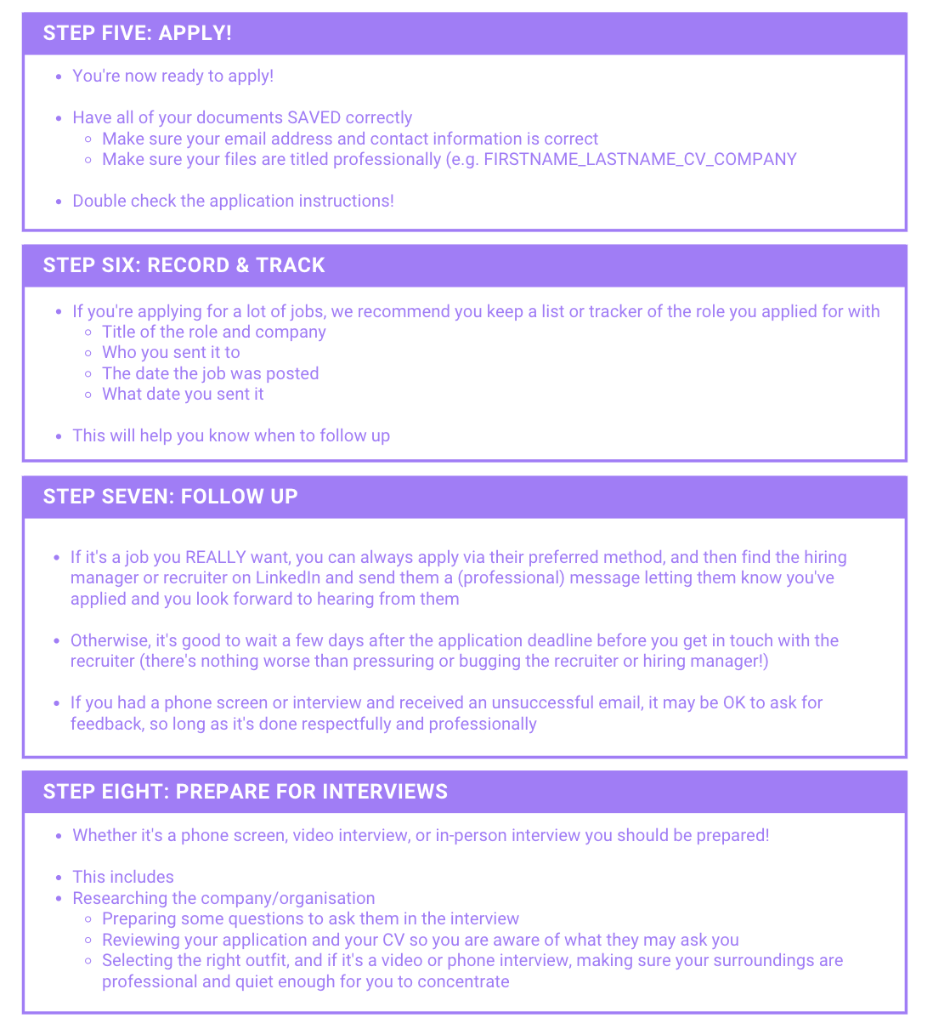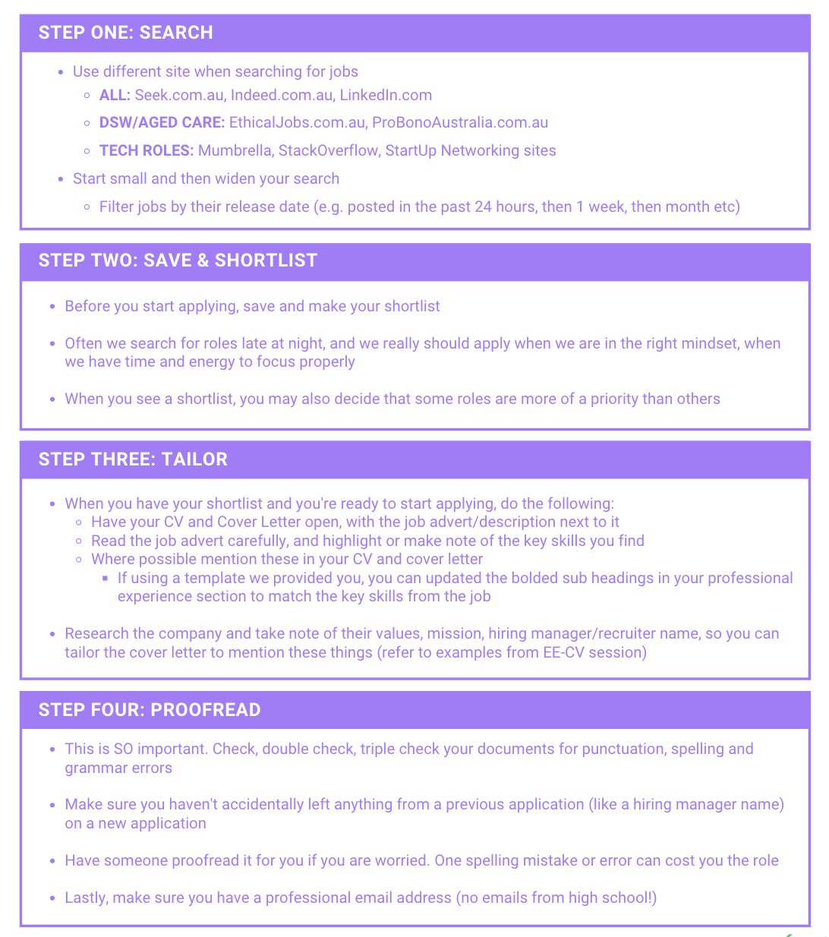

|  |  |
| --- | --- |
| Checklist for Applying for Jobs | |
| **Task** | **Notes** |
| * Does the job meet your preferences (time, location, industry, benefits etc)? |  |
| * Research and find name of Hiring Manager or recruiter |  |
| * Search the company for their values, mission statement or something about the organisation to include in your application |  |
| * Have highlighted the key words and skills from the advert in my cover letter |  |
| * Have used search filters to search the most recent roles first to increase chances |  |
| * Provided the documents they require |  |
| * Made sure to send my most updated versions which include links to my portfolio and Linkedin profile |  |
| * Tracked the application in a tracker, or the [Job & Application Tracker](https://docs.google.com/spreadsheets/u/1/d/1Iqmo3iU-hwjOCpFmaZrhHrhy0FvdTfcejK4pM7SVUMA/edit) here |  |
| * Have you completed the steps:  1. Search 2. Shortlist 3. Tailor CV and cover letter 4. PROOFREAD 5. Apply 6. Record and track 7. Follow up 8. Prepare for phone screen and interview |  |
| * Set up a professional email address |  |
| * Set up a professional voice message recording in case recruiters leave me messages |  |

## EE: Technical Interview Practise

|  |  |
| --- | --- |
| Interviews are a huge part of your job search - and the biggest opportunity you get to show your skills and suitability to the role you’re applying for. Part of your interviews will likely include:   * Questions about your technical knowledge of systems, terms and platforms * Questions about your technical experience and skills * Coding or problem solving challenges   Here are some resources for you on building your skills. Use the spaces below to record notes and further resources you find:  [LinkedIn Learning video collection](https://www.linkedin.com/learning-login/share?account=100575394&forceAccount=true&redirect=https%3A%2F%2Fwww%2Elinkedin%2Ecom%2Flearning%2Fcollections%2Fenterprise%2F1%7EAAAAAAX-qKI%3D443118%3FshareId=aa0d41bb-57e5-44db-b047-d58c8e4f8880)  [Interview Cake](https://www.interviewcake.com/python-interview-questions)  [Hacker Rank](https://www.hackerrank.com/auth/signup)  [Leet Code](https://leetcode.com/problemset/all/)  [Cracking the Code](https://www.crackingthecodinginterview.com/uploads/6/5/2/8/6528028/cracking_the_coding_skills_-_v6.pdf) | |
| Questions about technical knowledge or experience | Technical or coding challenges |
|  |  |

## EE: Mock Interviews

|  |  |  |
| --- | --- | --- |
| After completing the lessons on Interview Preparation, you will also have the chance to practice in Mock Interview sessions. Use the space below to record tips and also reflect on your interview performances. | | |
| Section | Practise Session 1 | Practise Session 2 |
| **Speaking**   * Pace of your talking * The volume * What to say |  |  |
| **Presentation and dress**  * Professional * Suitable for the workplace (i.e. if a Start Up, don’t wear a suit, but still be presentable) * What is your body language saying about you? |  |  |
| **Questions**  * Have I researched the role and the company and prepared some questions to ask the interviewers? |  |  |
| **Answers**  * It’s OK to say ‘that’s a good question, let me take a minute to think about the best example to share” * Provide structure: what the situation was, how you handled it, what you learnt |  |  |
| **Timing**  * Arrive early but not too early * Listen to the questions carefully, “Briefly tell us about yourself” doesn’t mean tell your whole story |  |  |

## SSM: Introduction to Post Program Support

|  |
| --- |
| You’ve made it!! How exciting!  We recommend you keep referring to this Student Workbook as you apply for roles and begin your career. The work you’ve done throughout the program will really support you in the first few months after graduation.  Use the rest of the space to take notes about the Post Program offering |
|  |

|  |
| --- |
| **Space for additional note taking** |
|  |

|  |
| --- |
| **Space for additional note taking** |
|  |